**HL Unit 7** **– Control**  
Quiz 2

|  |  |  |  |
| --- | --- | --- | --- |
| **Question 1** | | | |
| Objectives: | 7.1.1, 7.1.2, 7.1.4, 7.1.6 | Exam Reference: | May-15 12 |

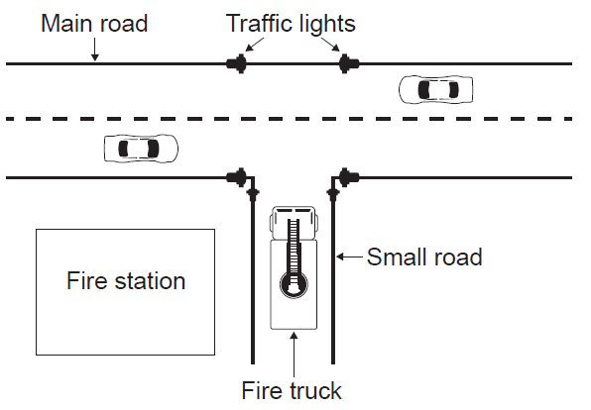  
In a town, a set of traffic lights control access from a small road, where a fire station is  
located, to a main road that has heavy traffic. In times of emergency, many vehicles from  
the fire station may need to leave the station at the same time. A system is put in place so  
that when a fire truck on the small road approaches the main road, the traffic lights switch to  
green (Go) on the small road and to red (Stop) on the main road.

1. Outline the role of sensors and a microprocessor in controlling the traffic lights in

this way. [4]

Sensors will be used to detect the approach of a vehicle from the minor road;

Likely to be touch/weight sensor embedded in the road;

Sensor input is converted from analog to digital;

To be processed and;

Signal sent to switch traffic lights;

1. Suggest how the traffic lights can be changed back to their original state once there are

no more fire trucks coming from the small road. [3]

These traffic lights are controlled by embedded systems at the point of use. It is proposed  
 that they should be controlled from the same central computer as all the other traffic lights in  
 the town.

*Award up to* ***[3 marks max]****.*

Continual feedback from sensor to processor;

A calculation based on number of vehicles/speed/*etc* or time taken for a vehicle to pass;

(Timer) resets if another vehicle is detected;

Once no input for a certain time traffic lights changed back;

1. Discuss the advantages and disadvantages of running the town’s traffic light system

on one central computer with multiple inputs and outputs. [5]

*Award* ***[2 marks]*** *for advantages,* ***[2 marks]*** *for disadvantages and* ***[1 mark]*** *for weighing up.*

***Disadvantages:***

Central computer would have to cope with inputs from many places;

With differing priorities which could take time;

Connection failure possible from a particular point;

Computer failure puts all lights in the area out;

Cost of communication system/central control system;

***Advantages:***

More control over traffic flow at these points;

Lights can be adapted from distance to avoid traffic blocks;

Any problem appearing at one point is known immediately and can be dealt with;

Cheaper as no need for communication software/hardware/control centre;

Can react/change rules to changing levels of traffic flow;

Overall, it would be better to ... *(appropriate conclusion)*;

A series of cameras are installed at each of the town’s traffic lights. These cameras are  
 connected to the central computer.

1. Discuss the social implications of monitoring traffic in this way. [3]

*Award* ***[1 mark]*** *for an advantage outlined,* ***[1 mark]*** *for a disadvantage outlined and* ***[1 mark]*** *for discussing.*

*For example:*

Controlling the movement of vehicles and identifying people who speed should help to reduce accidents (as motorists know that they will be caught if driving dangerously);

This could also save lives;

Individual displacement is tracked;

Which can be seen as an infringement on personal liberty/a breach of privacy;

In some cases the information could be used unjustly against the individual (*eg* in times of political unrest);

It comes down to physical safety on the road against privacy/personal liberty;

|  |  |  |  |
| --- | --- | --- | --- |
| **Question 2** | | | |
| Objectives: | 7.1.4, 7.1.7 | Exam Reference: | Nov-16 10 |

The temperature, humidity, light levels and automatic watering of plants inside the greenhouses (glasshouses) of a garden centre are centrally monitored and controlled.

1. Define the term analog data. [1]

Data represented by a continuous variable;

***Note:*** *Do not accept “not in digital format” or just examples.*

1. With reference to sensors, transducers and the processor, explain the control process

that takes place in the greenhouse (glasshouses). [5]

*Award* ***[1]*** *for outlining the purpose of each device, for all three devices.*

*Award* ***[2]*** *for explaining the importance of feedback in this relationship;*

*Example answer:*

Sensor: converts an inputted physical quantity (temperature, light, *etc*) into an electrical signal;

Processor: executes a set of instructions (programs) which control the

whole process;

Transducer: converts electrical signals into other forms of energy

(heat, light, *etc*);

Feedback: input signals (information about what is happening to a particular process in the greenhouses) is monitored;

And fed back to the processor where they can be used to make decisions whether to change/modify the climate in the greenhouses or not;

1. Outline the role of the operating system specific to this scenario. [4]

Operating system is a set of programs for this (dedicated) system;

Responsible for input devices (reading sensor data);

Responsible for sending to the output;

And reacting to inputted data in (predetermined) periods of time (to ensure the correct climate in the greenhouses);

***Note:*** *Correct answers must be specific to the scenario in question 10.*

1. Describe the difference between polling and interrupt in the event that some of the

sensors malfunction. [3]

*Example answer:*

*Polling:*

The CPU visits/checks each sensor in turn to see if there is some input data;

It will know that the sensor has malfunctioned;

*Interrupt:*

Each sensor sends data as required;

It will not know that the sensor has malfunctioned (unless a timer is set with a limit on the time between expected interrupts by a given sensor);

1. Compare a centrally controlled system with a distributed system. [2]

One computer/processor controls all the greenhouses;

Whilst in distributed system each of the greenhouses is monitored and controlled by its own computer;